1.
Summarizing data is easy with Excel. You just have to use the inbulit excel functions to accomplish this.

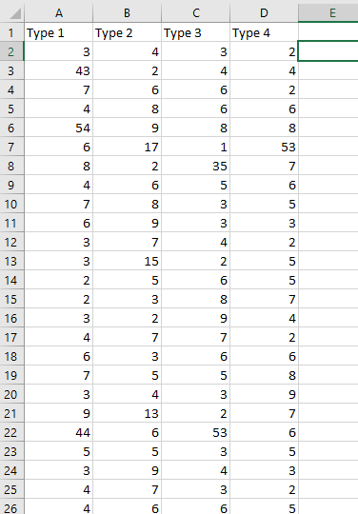

You have to divide the 400 tests into 4 different concrete mixtures, each with 100 tests.
You will summarize the data using these 4 groups.
You just have to include the minimum value, the maximum value, and the average of each of the four mixtures.

Create a table where the data will be input. As shown below:
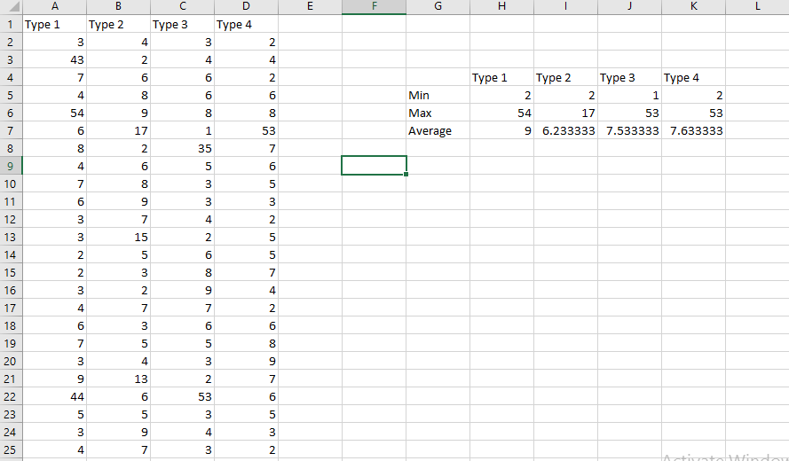
For each value to be calculated, a formula will be used to get the value.
Eg. Finding the minimum value among the Type 1 mixture tests. Click on the required cell, and on the text area above the cells, enter the command to calculate the minimum value, giving the range of data as input.
“=MIN(A2:A31)”
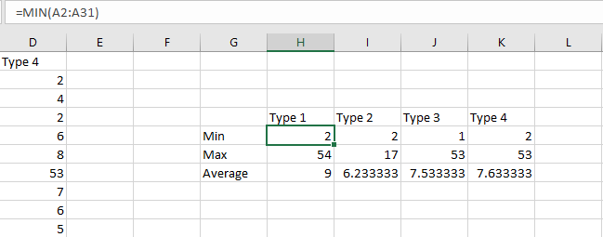

To find the maximum value of the mixture Type 1, enter the command “=MAX(A2:A31)” in the corresponding cell.
The average is calculated also using a funciton, AVERAGE, with the correct arguments for the range provided, ie. “=AVERAGE(A2:A31)”
For the rest of the cells, the same functions are used with the required arguments to give the appropriate results.
When completed, you now have the summary of the test results.

The function MIN is an inbuilt function used to calculate the minimum value among values. MAX is for finding the maximum value, while AVERAGE is for the average.

2.
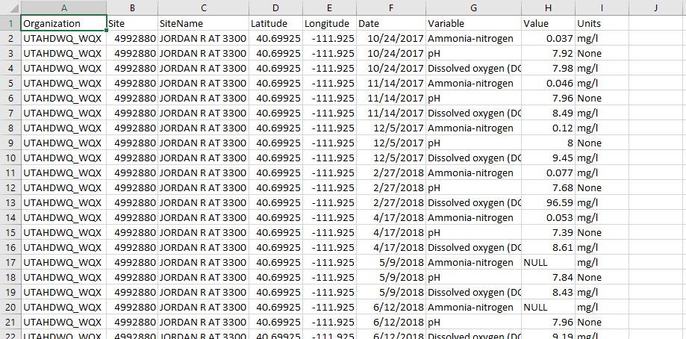
This is a sample of the data you would like to edit. H is the value’s column you want to edit. Changing all cells with a value of below 0.5 to NULL.

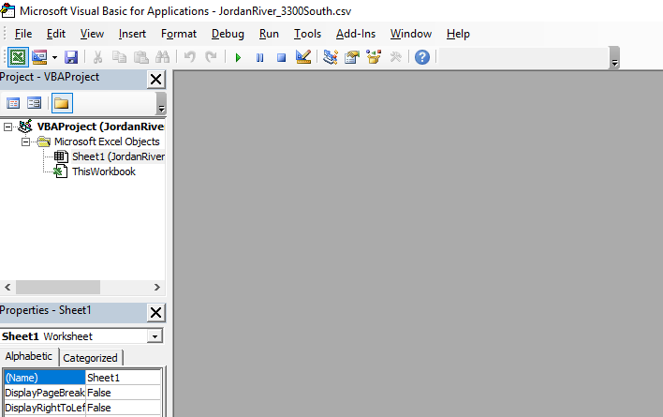

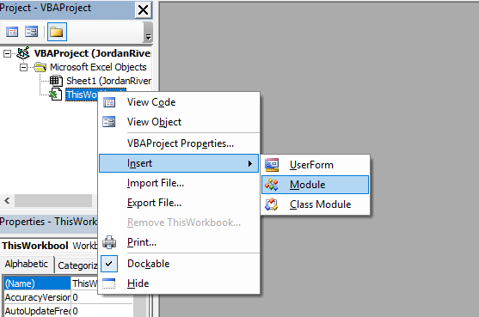

- You start VBA by pressing “Alt”+”F11”. Right click on the above panel, click on Insert, then Module.
A text area will appear. That’s where this code goes;

Sub Edit_Cells()
For i = 2 To 31
If Not Cells(i, 8).Value = "NULL" And Cells(i, 8) < 0.5 Then
Cells(i, 8) = "NULL"
End If
Next i
End Sub

The limits 2 and 31 mark the beginning and the end of the data being edited.

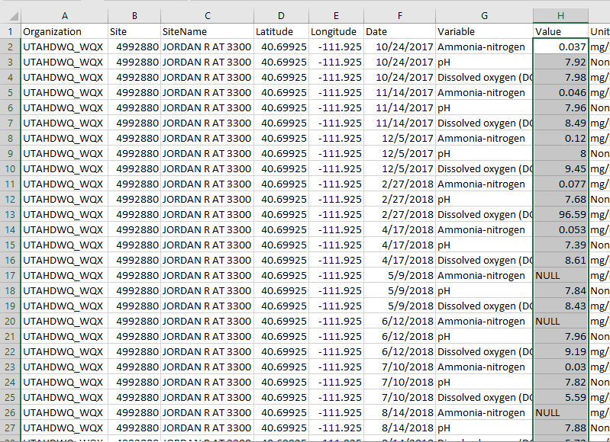
The highlighted values are the values we want to edit.

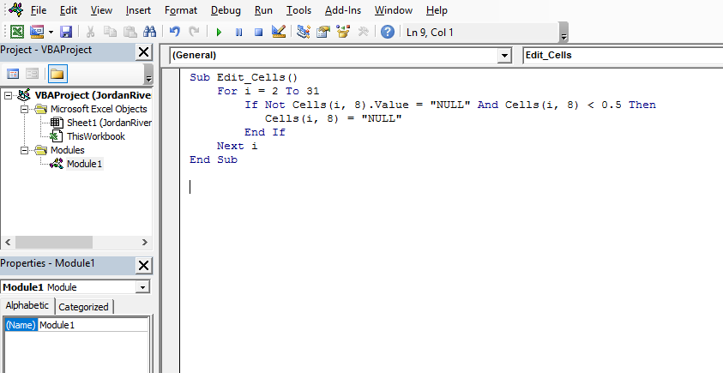
- Enter the code in the text area, then click the ‘Run’ button
A dialog box may appear. If so, just click ‘Run’ again.

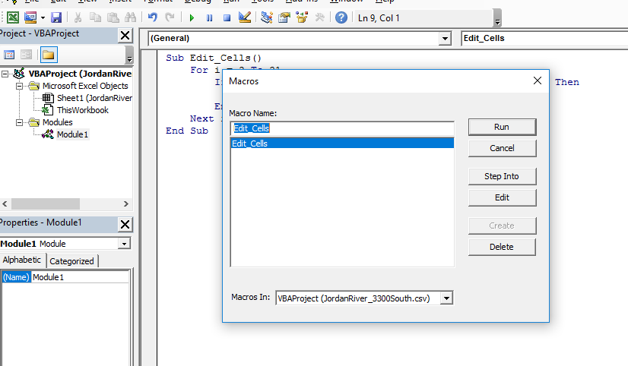

Now our data is as we wanted. You can now save the file.
The H column now does not have any value below 0.5.
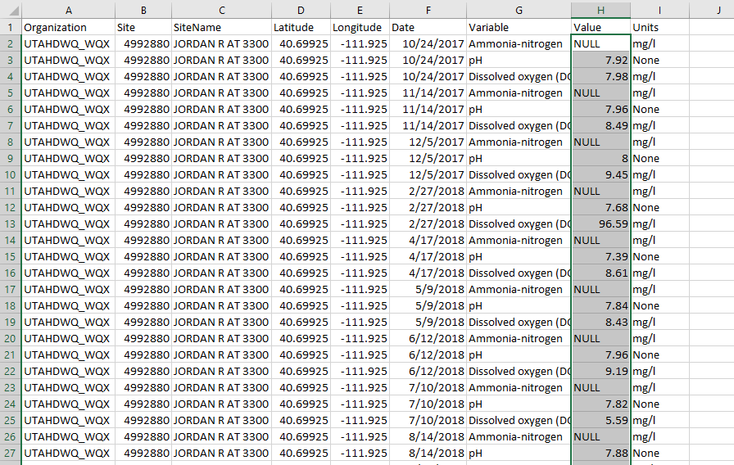

3.
The table below is the clients table from the database.
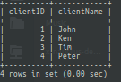

The orders table;

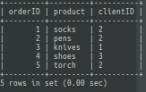

To get the number of orders for each client, you need to join the two tables, clients and orders. This is because the information needed is found in different tables.
You join the tables using ‘INNER JOIN’ command.
After you have one table with all the data required, you use the ‘COUNT’ command to count the quantity of the object you want.
Use the following MYSQL code to generate the final output;

SELECT clients.clientName, COUNT(*)
AS order_count
FROM clients
INNER JOIN orders
ON orders.clientID = clients.clientID
GROUP BY orders.clientID
ORDER BY clientName ASC;

You then use ‘ORDER BY’ to sort the data in the table, in the desired order.

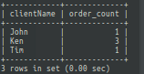
The above diagram shows the final table with the client’s name and number of orders each of the clients has.

4. The data that is to be entered is data that is relevant to the project at hand. This is data that needs to be stored for future reference, or to generate data that could give very helpful information that may aid in the execution of the project.
Since this is about a reinforced concret office building design, relevant data may include;
- Beam Design (Flexural design, Serviceability, Shear design)
- Column Design
- Slab Design
- Grid Floor Analysis & Design
- Staircase Design (Separate Excel spreadsheet)
- Combined Footing (Foundation analysis and design)
- Dome Design
- Isolated Footing
- 3 Hinged Arch Design
- Circular Beam
- Slender Column
- Bi-Axial Column
- Deflection Calculation
- DESIGN OF RETAINING WALL (Lateral earth pressure theory)
- DESIGN OF L Shaped Cantilever RETAINING WALL
- DESIGN OF Reverse L Shaped Cantilever RETAINING WALL

